**2 Marks:**

1. Define software?
2. What types of changes are made to legacy systems?
3. Many modern applications change frequently—before they are presented to the end user and then after the first version has been put into use. Suggest a few ways to build software to stop deterioration due to change.
4. What are the elements of a software process?
5. What are the five generic process framework activities?
6. Is software engineering applicable when WebApps are built? If so, how might it be modified to accommodate the unique characteristics of WebApps?
7. Umbrella activities occur throughout the software process. Do you think they are applied evenly across the process, or are some concentrated in one or more framework activities?
8. What is process flow?
9. What is a process pattern?
10. Why does the waterfall model sometimes fail?
11. What are the potential weaknesses of evolutionary process models?
12. What is an XP “story”?
13. Provide two examples of software projects that would be amenable to the incremental model.
14. List the dual role played by a software.

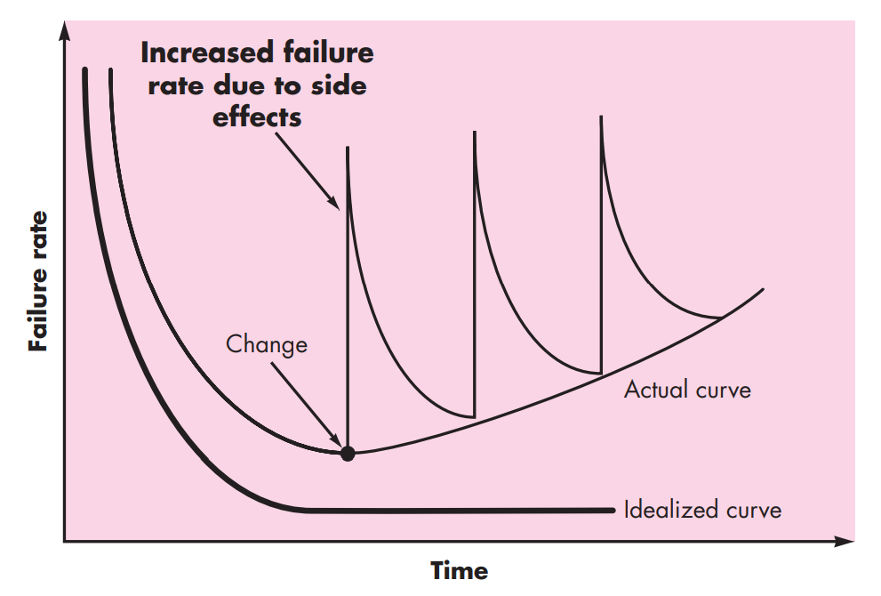

1. What does this figure depict in terms of software deterioration?
2. Most agile process models recommend face-to-face communication. Yet today, members of a software team and their customers may be geographically separated from one another. Do you think this implies that geographical separation is something to avoid? Can you think of ways to overcome this problem?

**4 Marks:**

1. How does a framework activity change as the nature of the project changes?
2. If formal methods can demonstrate software correctness, why is it they are not widely used?
3. Provide three examples of software projects that would be amenable to the waterfall model.
4. As you move outward along the spiral process flow, what can you say about the software that is being developed or maintained?
5. Is it possible to combine process models? If so, provide an example.
6. What new practices are appended to XP to create IXP?
7. Explain agility and cost of change with diagram.
8. List all agility principles.

**8 Marks:**

1. The process provides interaction between users and designers, between users and evolving tools, and between designers and evolving tools [technology]. List five questions that

* Designers should ask users,
* Users should ask designers,
* Users should ask themselves about the software product that is to be built,
* Designers should ask themselves about the software product that is to be built and the process that will be used to build it.

1. The concurrent process model defines a set of “states.” Describe what these states represent in your own words, and then indicate how they come into play within the concurrent process model.
2. Explain the seven broad categories of computer software challenges for software engineers.
3. Elaborate the software process framework.
4. Write an XP user story that describes the features available on a Web browsers.
5. Scenario – “ In a University, Requirement arises to digitize assessment process “. Explain the details in each step in Incremental process model with a maximum increment of 4 levels. Draw a neat diagram.
6. Explain and draw the spiral model for a maximum of three spirals for the following case study.

Passport provisioning system is to get the online registration form(with details such as name, date-of-birth, address etc.,) filled by the applicant whose testament is verified for its genuineness by the Passport Automation System with respect to the already existing information in the database. This forms the first round of verification done by the system, the information is in turn forwarded to the regional administrators office. The application is then processed manually based on the report given by the system, and any forfeiting identified can make the applicant liable to penalty as per the law. The system also provides the applicant the list of available dates for appointment to document verification in the administrators office, from which they can select one. The system forwards the necessary details to the police for its separate verification whose report is then presented to the administrator. The administrator will be provided with an option to display the current status of application to the applicant, which they can view in their online interface. After all the necessary criteria have been met, the original information is added to the database and the passport is sent to the applicant.

1. Discuss the advantages and disadvantages of the different types of software process models.